**PROPOSED STRUCTURAL MEASURES**

**MAHANADI – GODAVARI LINK –**

***PURPOSE-***

A quantum of 12,165Mcum is proposed for diversion through the link taking off at Manibhadra reservoir on Mahanadi to Dowlaiswaram Barrage on Godavari. This link will provide enroute irrigation benefits to the tune of 4.43 lakh hectares, of which 0.91 lakh hectares in Andhra Pradesh and 3.52 lakh hectares in Orissa. In this process it will utilize 3,790 Mcum of water. A provision of 802 Mcum is made for domestic and industrial water requirement enroute. The total length of the link canal is about 828 km including 6.15 km.of length through a tunnel. The total transmission loss of the link canal is worked out to be 1073 Mcum and proposes to transfer the remaining 6,500 Mcum of water to Godavari river for taking care of the water demands of further South. There is also a provision to generate 445 MW of hydropower at Manibhadra dam in this link canal proposal.

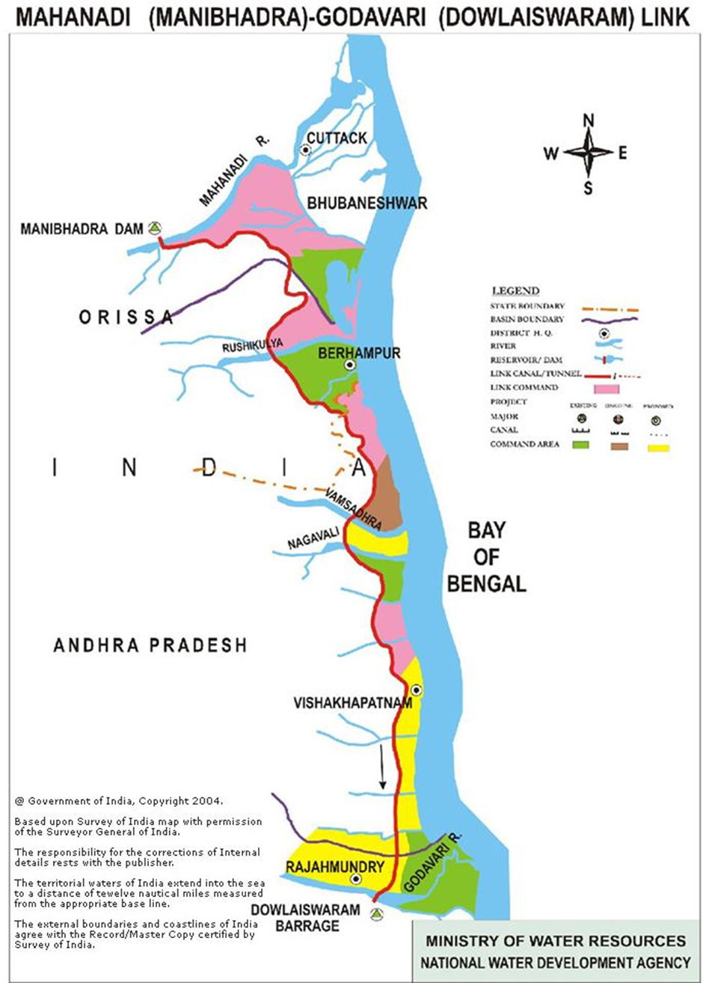

***ENGINEERING ASPECTS-***

A dam across the river Mahanadi in Orissa at Manibhadra as contemplated by the Government of Orissa is considered for diversion of water from Mahanadi to Godavari. The gross and live storages of the reservoir are 8,520 Mcum and 6,608 Mcum respectively. The diverted water will be received at the existing Sir Arthur Cotton (SAC) Barrage on Godavari at Dowlaiswaram in Andhra Pradesh. The total length of the link canal is about 828 km with FSLs at head and tail ponds being 74.00 m and 15.82 m, respectively. The designed discharge of the canal at the head is 802 cumecs and the canal is proposed to be operated throughout the year.

**WORK AT DIFFERENT LOCATION POINT**

***1. Godhaneswar Barrage to Bhanjanagar Reservoir-***

The pond level of the Godhaneswar barrage of Sindol Hydro-electric project is RL 100 m. so it is proposed to take a tunnel with bed level at 96 m. and connect it to Bhanjanagar Reservoir at level 86 m. the length of the tunnel is about 107 km. the slope of the tunnel will be 1:10000. From Bhanjanagar reservoir, water can be released to other system in the Rushikulya Basin to take up Rabi Irrigation. The maximum area that can be planned for future is 71.000 ha. of C.C.A. The discharge requirement will be 35 cumec.

***2. Manibhandra to Baghua Stage – I-***

The DSL of the proposed Manibhadra dam is 73.15 m. the pond level of the existing Baghua barrage is 66.30 m. so there is a head different of 6.85 m. Thus it is proposed to link Baghua Stage – I to Manibhadra at DSL to draw 35 cumec of water. The length of the tunnel will be about 75 km.

***3. Manibhadra to Bont Weir-***

The DSL of the proposed Manibhadra project is 73.15 m. the pond level of the Bont weir is 100 m. It is porposed to lift water up to RL 110 m. over a length of about 32.5 m. into a barrage over river Kuanria at latitude 20º19’30” N and longitude 84º50’ E, q1 near village Narasinghapur (downstream of Kuanria Dam). Water from this location can be transported through a tunnel for a length of 36 km. to Bont weir. From Bont, water can be distributed in the Rushikulya system.

***4. Manibhadra Canal near Kusumi crossing at RD 90 Km. to Buda weir-***

The approximate level of the proposed Manibhadra canal near Kusumi river crossing at RD 90 km. from where water has been proposed to be lifted and transported to Buda weir (pond level 100 m. RL) is 59.5 m. Water from Manibhadra canal can be lifted to a storage pond to level 105m, at longitude 20º03’10” N and latitude 85º03’ E located near village Pitalgarhia. The length of the lifting conduit may be 18 km with a head of a45.50 m. From here, water can be transported into the Buda weir through a tunnel for 25.0 km. discharging 35 cumec water for use in Rushikulya system.

***5. Manibhadra Canal near Kusumi Crossing at RD 94 km. to Dhanei Reservoir-***

The approximate level of the manibhadra Canal at Kusumi River crossing from where water has been proposed to be lifted and transported to Dhanei Reservoir (DSL -83.97 m). is 59.0 m. from the Dhanei project water will be distributed in Rushikulya system.

Water from the proposed Manibhadra Canal can be lifted to a storage pond to a level 100 m at latitude 200 03’ N and Longitude 850 04’ 30’ E near village Katarajhari. The length of the lifting system may be 16 Km. with a head of 31 m. from here, water can be transported into Dhanei reservoir (DSL 83.97, MWL 91.74m) through a tunnel of 35 km discharging 35 cumec to a level of 91.74m.

**THE PROJECT COMPRISES OF THE FOLLOWING COMPONENTS:**

Proposed Manibhadra project across Mahanadi river near Denkarasahi village in Gania Block of Nayagarh district in Orissa with FRL 86.00 m, MWL 91.5 m,MDDL (Minimum Draw Down Level) 73.15 m with gross storage capacity of 6000 Mm3, live storage capacity of 4290 Mm3 and a power house at toe of dam with an installed capacity of 960 MW.For the purpose of the proposed link canal, The FRL and MDDL of Manibhadra reservoir will be raised to 91.0 m and 74.15 m respectively and then the gross storage will be 8520 Mm3 and the live storage will be 6608 Mm3.

The 827.700 km long link canal is proposed to take off from the right hand of the reservoir Manibhadra at the FSL of 74.00 m. A head regulator on the right flank of Manibhadra dam and a canal power house of installed capacity of 70 MW with one 30 MW standby unit.

The Salia reservoir across Salia river near village Balugaon in BanpurTahasil of Khurda district in Orissa with FRL 58.52 m, gross storage capacity of 59.87 Mm3, live storage capacity of 51.97 Mm3 and MDDL of 48.82 m. The link canal is proposed to out fall into Salia reservoir and to take off from it at RD 144.0 km. It is proposed to raise the FRL of the reservoir to 63.30 m.

The existing Dowlaiswaram barrage across the river Godavari near Dowlaiswaram village in East Godavari district of Andhra Pradesh with a pond level of 13.64 m, to act as the final outfall point of the proposed link canal.

The link canal traverses through Nayagarh, Khurda, Ganjam and Gajapati districts of Orissa State and Srikakulam, Vizianagaram, Visakhapatnam and East Godavari districts of Andhra Pradesh. The proposed link canal is designed to discharge 801.98 cumec at head, 352.79 cumec at the tail end.

Out of 12165 Mm3 of water proposed for diversion from the Manibhadra reservoir, 3790 Mm3 would be used for en route irrigation in Orissa and Andhra Pradesh States. It is envisaged to provide irrigation to a culturable command area of 256770 ha and 107189 ha utilizing 3184 Mm3 and 606 Mm3 of water, respectively in Orissa and Andhra Pradesh States. The link canal power house with an installed capacity of 70 MW will generate 197 million units of energy every year.

Apart from irrigation, it is also proposed to provide about 802 Mm3 of water for meeting the future domestic and industrial requirements in the enroute command area of the link canal. Transmission loss in the link canal is estimated to be 1073 Mm3. It is envisaged that after meeting the projected requirements, out of the total diversion of 12165 Mm3, a quantum of 6500 Mm3 would be finally transferred to the Godavari River through the link canal.Direct net benefits per annum from the link project due to irrigation, domestic and industrial water supplies and power generation in the canal are estimated to be Rs. 116662 lakh.

The total cost of the link canal project is estimated to be Rs. 1754054 lakh at 2003-04 price level. Based on the quantity of water consumed enroute of the link canal, apportioned cost for enroute water supply is worked out to be Rs. 630182 lakhs and the annual cost to be Rs.71732 lakhs. The Benefit Cost Ratio works out to 1.60 and the Internal rate of return works out to 12.77%.